Floral Character Code

Only fertile Stamens considered (no staminodes)

0. Known Syndrome (eFLOWER Nr.: 22000)
0) Buzz
1) Nectar foraging vertebrates
2) Passerine
3) Selfing (not used)
4) Generalist
5) NA

1. Reward type - evaluated on fresh flowers in the field, ethanol-preserved material, and species descriptions (eFLOWER Nr.: 22001) *
0) Pollen
1) Nectar
2) Food body
3) Nectar/Pollen – Generalist – removed -> becomes 1
4) Oil/Pollen

2. Pollen expulsion mechanism - evaluated on fresh flowers in the field, ethanol-preserved
material and species descriptions (eFLOWER Nr.: 22002)
0) Buzzing (vibratile)
1) Bellows
2) Salt-shaker – flowers nodding
3) Bounce
4) Messy – Generalist insect assemblage or upright flowers visited by nectar foraging vertebrates. Pollen released easily on touch (MICBAR)
5) Slit – Anthers open via longitudinal open slit; pollen is easily accessible (some have slit and are still buzz-bee pollinated e.g. Mouriri brevipes)

3. Orientation of flowers in inflorescence - evaluated on photos, herbarium specimens, and species descriptions and considering the majority of flowers (eFLOWER Nr.: 22003)
0) Multiple
1) Upright-horizontal
2) Nodding

4. Petal length – numeric (mm). measured from the base of the petal to the tip - evaluated on fresh flowers and drawings, herbarium vouchers and species descriptions (eFLOWER Nr.: 22004) *

5. Corolla shape – assessed at mid-anthesis (thus excluding opening buds (which at first will all
resemble cupule/funnel shapes) and senescent flowers (which will have opened more in certain
species)). evaluated on photos. ethanol-preserved material and herbarium vouchers (eFLOWER Nr.: 22005) *
0) Flat (flowers open, petals forming a landing platform, tips can be reflexed)
1) Solanum-type (flowers open, petals strongly reflexed, not forming a landing platform)
2) Bowl-shaped or campanulate-salverform (flowers relatively open but petals not flat, forming an open bowl (no constrictions))
3) Campanulate (bell-shaped, widening towards opening)
4) Urceolate (bell-shaped, opening narrower than the maximum corolla diameter)
5) Tube (petals forming a narrow corolla tube, not widened at the opening)
6) Short erect (petal short and upright, but not forming a bowl – not overlapping)
7) Cleistoflor (flowers do not open)

6. Corolla color - evaluated on photos. in the field. and derived from species descriptions and
herbarium labels (eFLOWER Nr.: 22006) *
0) White
1) Light pink
2) Red
3) Salmon
4) Fuchsia
5) Orange
6) Lilac
7) Yellow
8) Light Green
9) Purple
10) Pink
11) Blue

7. Stamen dimorphism – evaluated on photos. ethanol-preserved material. drawings. species
descriptions and herbarium vouchers (eFLOWER Nr.: 22007)
0) Isomorphic (if staminodes present not included in analyses – only functional stamens)
1) Slightly dimorphic (small difference in shape or size. but no clear heteranthery)
2) Strongly dimorphic (heteranthery)
3) Staminodes

8. Level of anther pore - height of the anther pores relative to the style length. evaluated on
ethanol-preserved material. photos and herbarium vouchers (eFLOWER Nr.: 22008)
0) Top (Pore higher than stigma)
1) Middle or lower than stigma (Pore in middle of style – between same and bottom)
2) Bottom (Pore at bottom of style)
3) Same (Pore on +-same level as Stigma)
4) Higher and Lower (in species with strong stamen dimorphism)

9. Shape of dorsal stamen appendage of antesepalous stamen – evaluated on ethanol-preserved material. Herbarium vouchers, drawings and species descriptions (eFLOWER Nr.: 22009)
0) Bifurcate (often elongated and bifurcated) = V-Shaped, e.g., Diplectria conica
1) Knob (protrusion bending away from connective strand), e.g., Blakea grandiflora
2) Nose (rounded structure bending towards pore. in direction of connective strand), e.g., Opisthocentra clidemioides
3) Absent
4) Klub-shaped or mixed bifurcate/club-shaped or mixed club-shaped/knob (mixed
conditions apply to some heterantherous species), e.g., Microlicia cordata
5) Upside-down heart, e.g., Tibouchina aspera
6) Bellows, e.g., Axinaea macrophylla
7) Thread-like downwards (Thread-like – thread points downwards), e.g., Blakea superba
8) Acuminate, e.g., Miconia micayana
9) Filiform wings, e.g., Brasilianthus carajensis
10) Thread-like upwards, e.g., Monochaetum exaltatum
11) Fusiform, e.g., Graffenrieda fruticosa
12) Trident, e.g., Dalenia sarawakensis
13) Bulbous, e.g., Miconia myriantha
14) Tuft of hair, e.g., Macrolenes tuberculata
15) Crown, e.g., Meriania costata
16) Pyramidal, e.g., Meriania nobilis

10. Shape of dorsal stamen appendage of antepetalous stamen – evaluated on ethanol-preserved material. Herbarium vouchers, drawings and species descriptions (eFLOWER Nr.: 22010)
0) Bifurcate (often elongated and bifurcated) = V-Shaped, e.g., Eleotis welwitschii
1) Knob (protrusion bending away from connective strand), e.g., Blakea grandiflora
2) Nose (rounded structure bending towards pore. in direction of connective strand), e.g., Opisthocentra clidemioides
3) Absent
4) Klub-shaped or mixed bifurcate/club-shaped or mixed club-shaped/knob (mixed
conditions apply to some heterantherous species), e.g., Meriania radula
5) Upside-down heart, e.g., Tibouchina aspera
6) Bellows, e.g., Axinaea macrophylla
7) Thread-like downwards (Thread-like – thread points downwards), e.g., Blakea superba
8) Acuminate, e.g., Miconia micayana
9) Filiform wings, e.g., Macrolenes tuberculata
10) Thread-like upwards, e.g., Monochaetum exaltatum
11) Fusiform, e.g., Graffenrieda fruticosa
12) Trident, e.g., Miconia argyrophylla
13) Bulbous, e.g., Macairea rufescens
14) Tuft of hair, e.g., Pachycentria pulverulenta
15) Crown, e.g., Meriania costata
16) Pyramidal, e.g., Meriania nobilis
17) Antepetalous stamens absent (if absent or staminodes), e.g., Alloneuron ulei

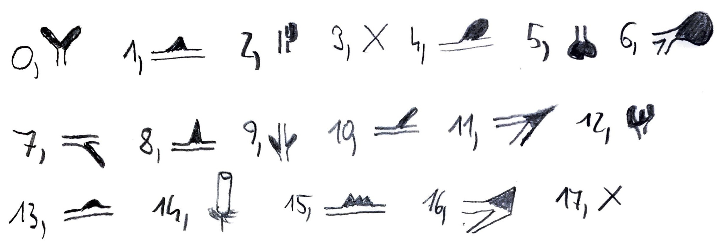

11. Shape of ventral stamen appendage of antesepalous stamen – evaluated on ethanol-preserved material. Herbarium vouchers, drawings and species descriptions. Ventral of filament or pointing towards the floral center if a 2nd dorsal and no other ventral appendage is present e.g., Adelobotrys adscendens. (eFLOWER Nr.: 22011) Appendage can be inflated base of theci or prolonged connective.
0) Acuminate (small spine, separate from thecae), e.g., Meriania nobilis
1) Bulbous-acuminate
2) Bellows (similar width:length, ratio 0.5 to > 1), e.g., Meriania macrophylla
3) Crown (similar to pyramidal but ending in a rugged tip (instead of an acuminate one))
4) Fusiform (elongated, width:length < 0.25; more direct transition into thecae), e.g., Rhexia virginica
5) Pyramidal (triangular acuminate pyramid, width:length > 0.33, including species
with more distant thecae.
6) Knob like, e.g., Meriania costata
7) Upside-down heart, e.g., Chaetogastra cerastifolia
8) V-Shape, e.g., Chaetogastra grossa
9) Thread-like downwards (thread points downwards, towards flower)
10) Thread-like upwards (thread points upwards, away from flower, e.g., Merianthera eburnea
11) Trident, e.g., Argyrella richardsiae
12) Hooked
13) Lateral flaps, e.g., Miconia argentea
14) No App
15) U-Shape, e.g., Acisanthera uniflora
16) Filiform wings, e.g., Amphorocalyx multiflorus
17) Tuft of hairs
18) Bar-like
19) Klub Shape, e.g., Amphiblemma cymosum
20) Bulbous, e.g., Calvoa hirsuta

12. Shape of Ventral stamen appendage of antepetalous stamen – evaluated on ethanol-preserved material. Herbarium vouchers. drawings and species descriptions. Ventral of filament or pointing towards the floral center if a 2nd dorsal and no other ventral appendage is present e.g., Adelobotrys adscendens. (eFLOWER Nr.: 22012) Appendage can be inflated base of theci or prolonged connective.
0) Acuminate (small spine, separate from thecae), e.g., Meriania maxima
1) Bulbous-acuminate
2) Bellows (similar width:length, ratio 0.5 to > 1), e.g., Meriania macrophylla
3) Crown (similar to pyramidal but ending in a rugged tip (instead of an acuminate one))
4) Fusiform (elongated, width:length < 0.25; more direct transition into thecae), e.g. Rhexia virginica
5) Pyramidal (triangular acuminate pyramid, width:length > 0.33, including species
with more distant thecae.
6) Knob like, e.g., Meriania costata
7) Upside-down heart, e.g., Chaetogastra minor
8) V-Shape (e.g., Chaetogastra grossa)
9) Thread-like downwards (thread points downwards, towards flower)
10) Thread-like upwards (thread points upwards, away from flower), e.g., Merianthera eburnea
11) Trident, e.g., Dichaetanthera cordifolia
12) Hooked
13) Lateral flaps, e.g., Miconia argentea
14) No App
15) U-Shape, e.g., Tessmannianthus carinatus
16) Filiform wings, e.g., Amphorocalyx multiflorus
17) Tuft of hair
18) Bar-like
19) Klub Shape, e.g., Boyania colombiana
20) Bulbous, e.g., Calvoa hirsuta
21) Antepetalous stamens absent (if absent or staminodes), e.g., Allomaieta hirsuta
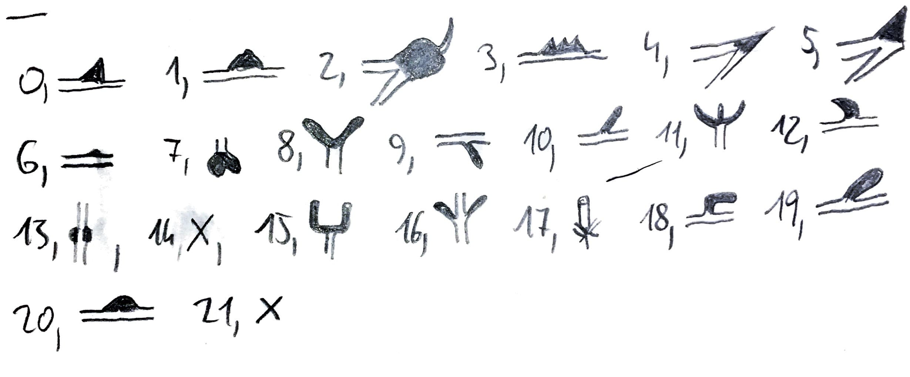
13. Location of thecae on connective – evaluated on ethanol-preserved material. herbarium
vouchers. drawings and species descriptions (eFLOWER Nr.: 22013)
0) Ventral (thecae restricted to ventral side of connective strand in relation to floral center)
1) Lateral (thecae attached at sides of connective strand. pollen chambers supinated)
2) Dorsal
3) Ventral/Dorsal (in dimorphic species, if one stamen set has ventral and the other set dorsal theci in relation to the floral center)

14. Antesepalous anther shape – evaluated on ethanol-preserved material. herbarium vouchers. drawings and species descriptions (eFLOWER Nr.: 22014)
0) Acuminate (continuous narrowing towards the pore. width at pore considerably less
than on top)
1) Oblong (oblong anther which only narrows just before the pore but remains more or
less the same thickness)
2) Acuminate/oblong (dimorphic stamens)

15. Antepetalous anther shape – evaluated on ethanol-preserved material. herbarium vouchers. drawings and species descriptions (eFLOWER Nr.: 22015)
0) Acuminate (continuous narrowing towards the pore. width at pore considerably less
than on top)
1) Oblong (oblong anther which only narrows just before the pore but remains more or
less the same thickness)
2) Acuminate/oblong (dimorphic stamens)
3) Antepetalous stamens absent (if absent or staminodes)

16. Recurving of antesepalous anther – evaluated on ethanol-preserved material. herbarium vouchers, drawings and species descriptions drawings and species descriptions (eFLOWER Nr.: 22016)
0) Yes (concave shape of anthers)
1) No

17. Recurving of antepetalous anther – evaluated on ethanol-preserved material. herbarium vouchers, drawings and species descriptions drawings and species descriptions (eFLOWER Nr.: 22017)
0) Yes (concave shape of anthers)
1) No
2) Antepetalous stamens absent (if absent or staminodes)

18. Structure of adaxial thecal wall – evaluated on ethanol-preserved material. herbarium
vouchers. drawings and species descriptions (eFLOWER Nr.: 22018)
0) Ruminate (at least in one stamen whorl. along the entire thecal length or at the base of
the thecae; sturdy and strongly folded. made up by more than one tightly arranged cell
layer (possibly a remaining tapetum), cannot be deformed when slight pressure is
applied from the outside) e.g., buzzing
1) Smooth (sturdy but smooth. not folded. made up by one tightly arranged cell layer
and strong cuticle and remnants of tapetum, cannot be deformed when slight pressure
is applied from the outside) e.g., Bellows, longitudinal slits (except Astroniae – missing endothecium (Mancera 2017 -> Crumpled)), slit like pores
2) Crumpled (soft and flexible. made up by one more loosely arranged cell layer, easily
deformable when pressure is applied from the outside) e.g., salt shaker, messy

19. Anther opening - evaluated on ethanol-preserved material, herbarium vouchers, drawings and species descriptions (eFLOWER Nr.: 22019
0) Pore
1) Longitudinal slit (if 2/3 of theci are opening via 1 slit – making pollen easily accessible
3) Slit like pores (2 small slits – not making pollen easily accessible e.g., still needs buzzing to remove pollen)

20. Location of stamen pore of antesepalous stamen in relation to floral center – evaluated on ethanol-preserved material, herbarium vouchers, drawings and species descriptions eFLOWER Nr.: 22020)
0) Apical
1) Dorsal
2) Dorsal apical (e.g., when anthers curved – pore is dorsal but points upwards / Pore is apical but points outwards)
3) Ventral
4) Ventral apical (pore is ventral but points upwards / pore is apical but points inwards)

21. Location of stamen pore of antepetalous stamen in relation to floral center – evaluated on ethanol-preserved material, herbarium vouchers, drawings and species descriptions eFLOWER Nr.: 22021)
0) Apical
1) Dorsal
2) Dorsal apical (e.g., when anthers curved – pore is dorsal but points upwards / Pore is apical but points outwards)
3) Ventral
4) Ventral apical (pore is ventral but points upwards / pore is apical but points inwards)
5) Antepetalous stamens absent (if absent or staminodes)

22. Relative position of stigma to corolla opening (flower viewed from the side) – evaluated on
ethanol-preserved material. herbarium vouchers. drawings and species descriptions (eFLOWER Nr.: 22022)
0) Free (style usually visible in its full length) 80-100% free
1) Partly enclosed (upper quarter of the style usually visible) 20-80% free
2) Enclosed (style mostly enclosed by petals. not (or only tip of stigma) visible) < 20% free

23. Style curvature – evaluated on ethanol-preserved material. herbarium vouchers. drawings
and species descriptions (eFLOWER Nr.: 22023)
0) Curved (curved. sometimes straight)
1) Hook (clear hook at the tip)
2) Straight

24. Androecial position relative to style – evaluated on fresh flowers and photos, herbarium vouchers, drawings and species descriptions, viewed from the front (eFLOWER Nr.: 22024)
0) Adaxial (Stamens form a half circle above the style, zygomorphic)
1) Abaxial (Stamens from a half circle below the style, zygomorphic)
2) Circulate (full circle around the style)

25. Orientation of pore from antesepalous stamen and stigma – in heterantherous species, stamens were measured separately; in isomorphic species, the same value/score was used for all stamens - evaluated on fresh flowers, herbarium vouchers and pickled material using binocular microscopy, on drawings and species descriptions (eFLOWER Nr.: 22025)
0) Pore points away from stigma
1) Pore faces stigma

26. Orientation of pore from antepetalous stamen and stigma – in heterantherous species, stamens were measured separately; in isomorphic species, the same value/score was used for all stamens - evaluated on fresh flowers, herbarium vouchers and pickled material using binocular microscopy, on drawings and species descriptions (eFLOWER Nr.: 22026)
0) Pore points away from stigma
1) Pore faces stigma
2) Antepetalous stamens absent (if absent or staminodes)

27. Color contrast between corolla and reproductive organs – evaluated on fresh flowers and photos, drawings, herbarium labels and species descriptions (eFLOWER Nr.: 22027) *
0) Yes
1) No

28. Stigma shape - interpreted when placing the style upright and looking at the stigma from the side (possibly related to pollen pick-up) - evaluated on fresh flowers and photos, drawings, herbarium vouchers and species descriptions (eFLOWER Nr.: 22028)
0) Corymbose (umbrella-shape, overarching the width of the style but usually shorter than wide, sometimes almost rounded like a ball)
1) Convex (bump, shorter than wide, but not overarching style width)
2) Conical (elongated, as long or longer than wide, not overarching style width)
3) Stamp (almost flat, about as wide as the style, neither narrowing nor widening)

29. Stigma diameter – measured on 3D scans of flowers, mean taken (numeric (mm)); (possibly related to pollen pick-up, Cruden 2000), or obtained from species descriptions (eFLOWER Nr.: 22029)

30. Extent of floral projection from foliage - evaluated on fresh flowers and photos, drawings, herbarium vouchers and species descriptions (eFLOWER Nr.: 22030)
0) Sessile (no pedicel or so short that it is not visible on pictures, < 1mm)
1) Intermediate (clearly visible pedicel - from very short to very long – not projected over leaves)
2) Flagelliflor (flowers clearly projected from foliage – relation to leaves)

31. Anther length of antepetalous stamens (connective + theci) - evaluated on fresh flowers and drawings, herbarium vouchers and species descriptions (numeric (mm)), 0 if only one set of stamens (eFLOWER Nr.: 22031)

32. Anther length of antesepalous stamens (connective + theci) - evaluated on fresh flowers and drawings, herbarium vouchers and species descriptions (mm), (eFLOWER Nr.: 22032)

33. Fruit type - evaluated in the field as well as using photos, drawings, herbarium vouchers and species descriptions (eFLOWER Nr.: 22033)
0) Berry
1) Capsule

34. Ventral appendage length of antepetalous Stamens (mm) - evaluated on fresh flowers and drawings, herbarium vouchers and species descriptions, 0 if only one set of stamens or if appendage is absent (eFLOWER Nr.: 22034)

35. Ventral appendage length of antesepalous Stamens (mm) - evaluated on fresh flowers and drawings, herbarium vouchers and species descriptions, 0 if appendage is absent (eFLOWER Nr.: 22035)

36. Anther pore width of antepetalous Stamens (mm) - evaluated on fresh flowers and drawings, herbarium vouchers and species descriptions, 0 if only one set of stamens (eFLOWER Nr.: 22036)

37. Anther pore height of antepetalous Stamens (mm) - evaluated on fresh flowers and drawings, herbarium vouchers and species descriptions, 0 if only one set of stamens (eFLOWER Nr.: 22037)

38. Anther pore width of antesepalous Stamens (mm) - evaluated on fresh flowers and drawings, herbarium vouchers and species descriptions (eFLOWER Nr.: 22038)

39. Anther pore height of anteseplaous Stamens (mm) - evaluated on fresh flowers and drawings, herbarium vouchers and species descriptions (eFLOWER Nr.: 22039)

40. Pollinator(s) – personal observations and pollinator descriptions (eFLOWER Nr.: 22040)

41. Nr. Of Pores/Slit(s) - evaluated on fresh flowers and photos, drawings and species descriptions (eFLOWER Nr.: 22041)
0) 1
1) 2
2) 4
3) 1 and 2 (if anthers are strongly dimorphic and have different number of pores)

42. Dorsal appendage length of antepetalous Stamens (mm) - evaluated on fresh flowers and drawings, herbarium vouchers and species descriptions, 0 only one set of stamens or if appendage is absent (eFLOWER Nr.: 22042)

43. Dorsal appendage length of antesepalous Stamens (mm) - evaluated on fresh flowers and drawings, herbarium vouchers and species descriptions, 0 only one set of stamens or if appendage is absent (eFLOWER Nr.: 22043)

44. Funktion of appendage – personal observations and pollination descriptions (eFLOWER Nr.: 22044)
0) Bellows
1) Handle
2) Rudiment / might attract pollinators (e.g., color, nectar aggregation)
3) No function - absent

45. Total pore size antepetalous anther – average for a single anther(Pore height * Pore width * 3,14 * Number of pores in mm²) (eFLOWER Nr.: 22045)

46. Total pore size anteseplalous - average for a single anther (Pore height * Pore width * 3,14 * Number of pores in mm²) (eFLOWER Nr.: 22046)

47. Total pore size – sum of an antepetalosu and an antesepalous anther (Total pore size antepetalous anther + Total pore size anteseplalous in mm²) (eFLOWER Nr.: 22047)

48. Relative pore size anthesepalous (mm) – pore size (mm²) divided by anther size (mm) (eFLOWER Nr.: 22048)

49. Relative pore size anthepetalous (mm) – pore size (mm²) divided by anther size (mm) (eFLOWER Nr.: 22049)

50. Total relative pore size (mm) – sum of relative pore size anthepetalous and anthesepalous (mm) (eFLOWER Nr.: 22050)

51. Appendage bellows or not - valuated on fresh flowers and drawings, herbarium vouchers and species descriptions (eFLOWER Nr.: 22051).
0) Yes (if one of the anther whorls possess a bulbous dorsal appendage)
1) No

Summary:

- General traits: 7 (Traits: 0, 1, 2, 3, 30, 33, 40)
- Corolla traits: 3 (Traits: 4, 5, 6)
- Androecium traits: 23 (Traits: 7, 9- 21, 31, 32, 34 - 39, 41)
- Gynoecium traits: 3 (Traits: 23, 28, 29)
- Mixed: 6 (Traits: 8, 22, 24, 25, 26, 27)
- Classic pollination syndrome traits indicated by * (1, 4, 5, 6, 27)

