**Supplementary material**

**Exploration and foraging behavior: A field validation of the neophobia threshold hypothesis**

Jefferson García-Loor1,2, Andrew C. Katsis1,2,3, Lauren K. Common1,2,3 and Sonia Kleindorfer1,2,3.

1 Department of Behavioral and Cognitive Biology, University of Vienna, 1030, Austria

2 Konrad Lorenz Research Center for Behavior and Cognition, University of Vienna, 4645, Austria

3 College of Science and Engineering, Flinders University, Adelaide, 5001, Australia

# Corresponding author:

Jefferson García-Loor, [garcialoorjefferson@gmail.com](mailto:garcialoorjefferson@gmail.com)

**Figure S1.** Correlation between the two exploration variables (total sector visits, unique sector visits) measured during the novel environment test. Species abbreviations: small ground finch (SGF), medium ground finch (MGF), small tree finch (STF), medium tree finch (MTF), Galápagos flycatcher (GFC), and yellow warbler (YW).

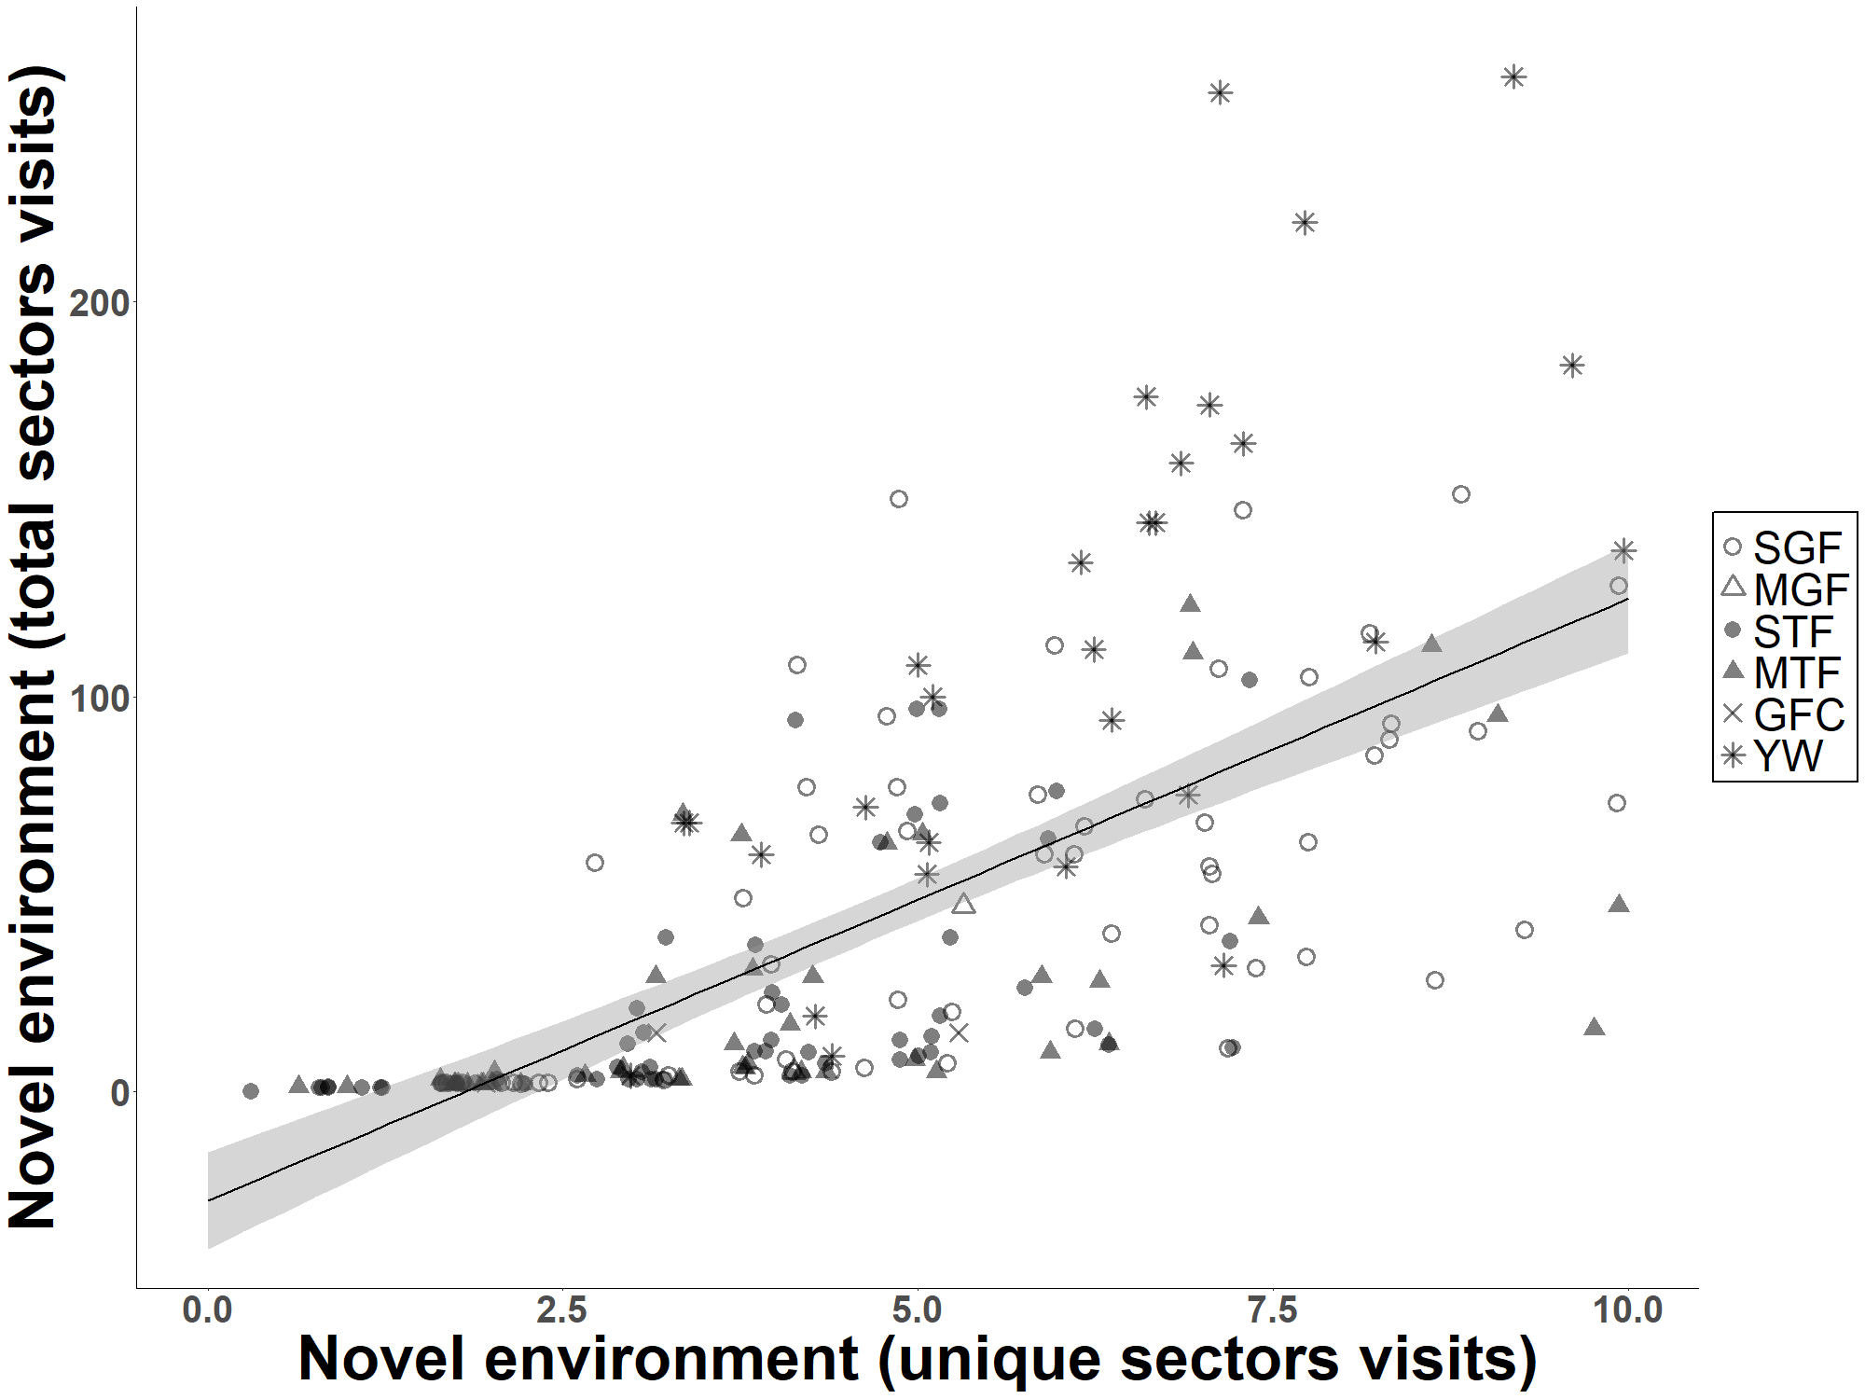

**Figure S2.** Correlation between the total sector visits measured during the novel environment test and the latency to approach into 10 m to the novel object, during the novel object test. Species abbreviations: small ground finch (SGF), medium ground finch (MGF), small tree finch (STF), medium tree finch (MTF), Galápagos flycatcher (GFC), and yellow warbler (YW).

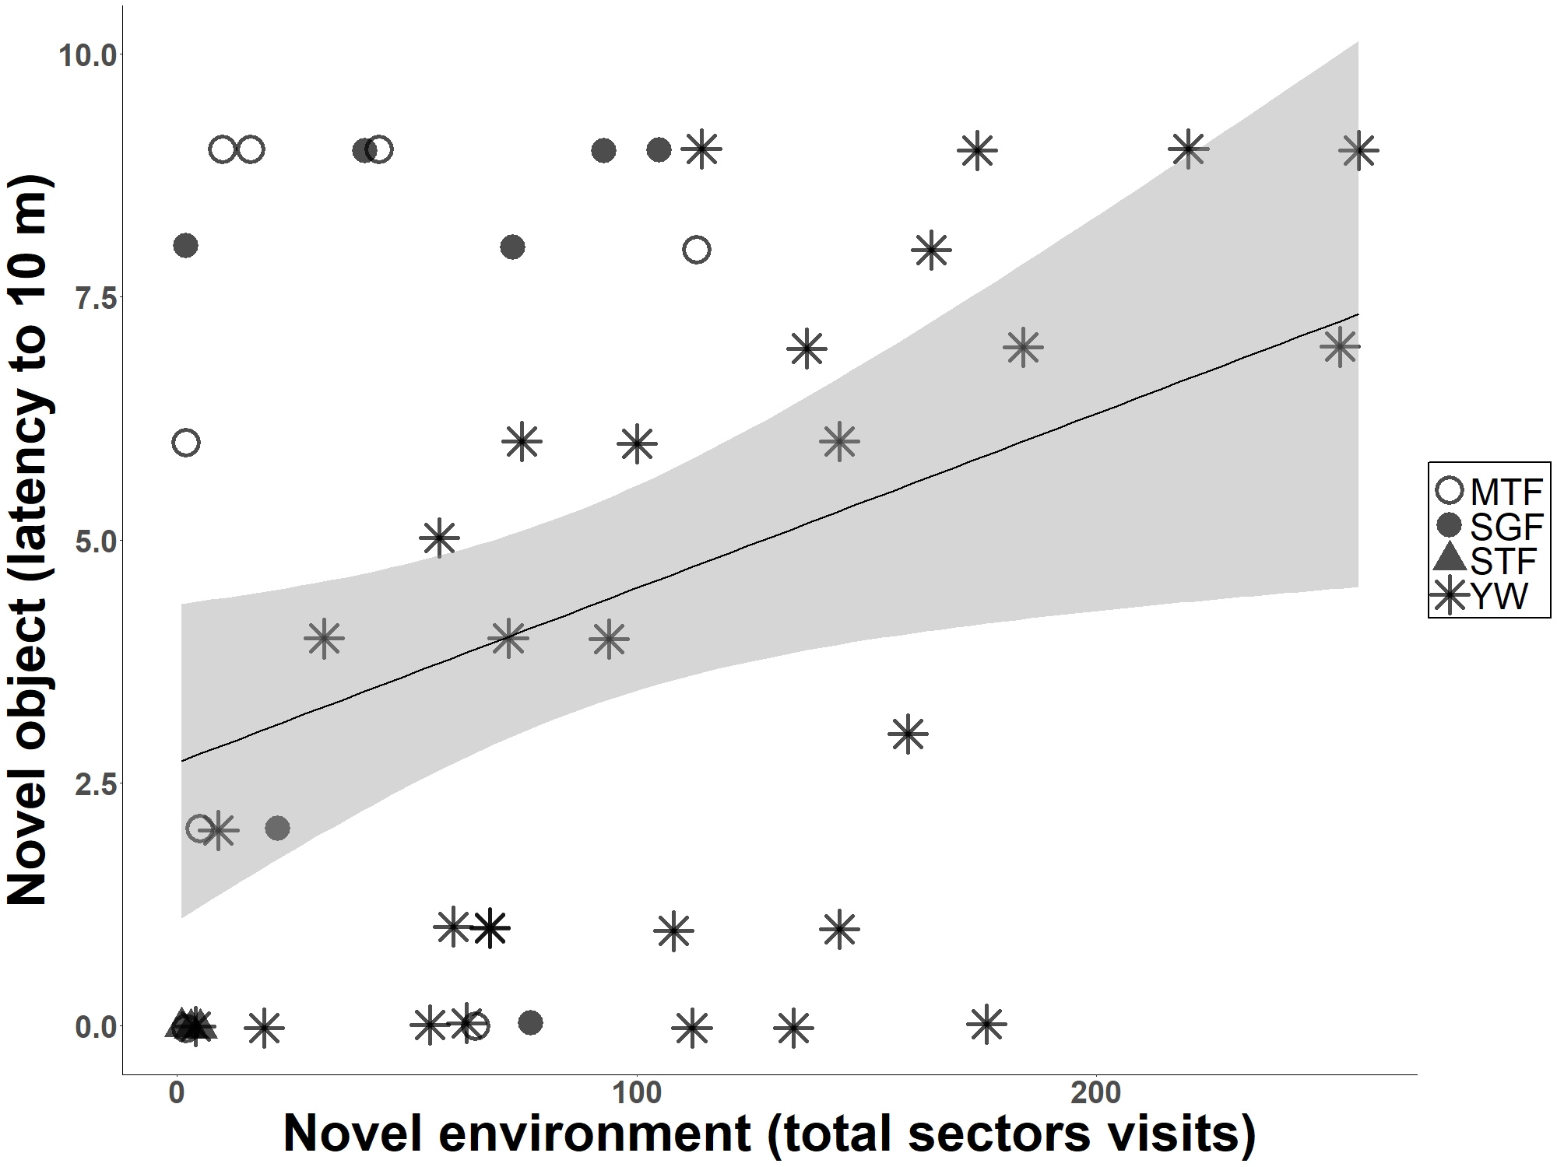

**Figure S3.** Correlation between the unique sector visits measured during the novel environment test and the latency to approach into 10 m to the novel object, during the novel object test. Species abbreviations: small ground finch (SGF), medium ground finch (MGF), small tree finch (STF), medium tree finch (MTF), Galápagos flycatcher (GFC), and yellow warbler (YW).

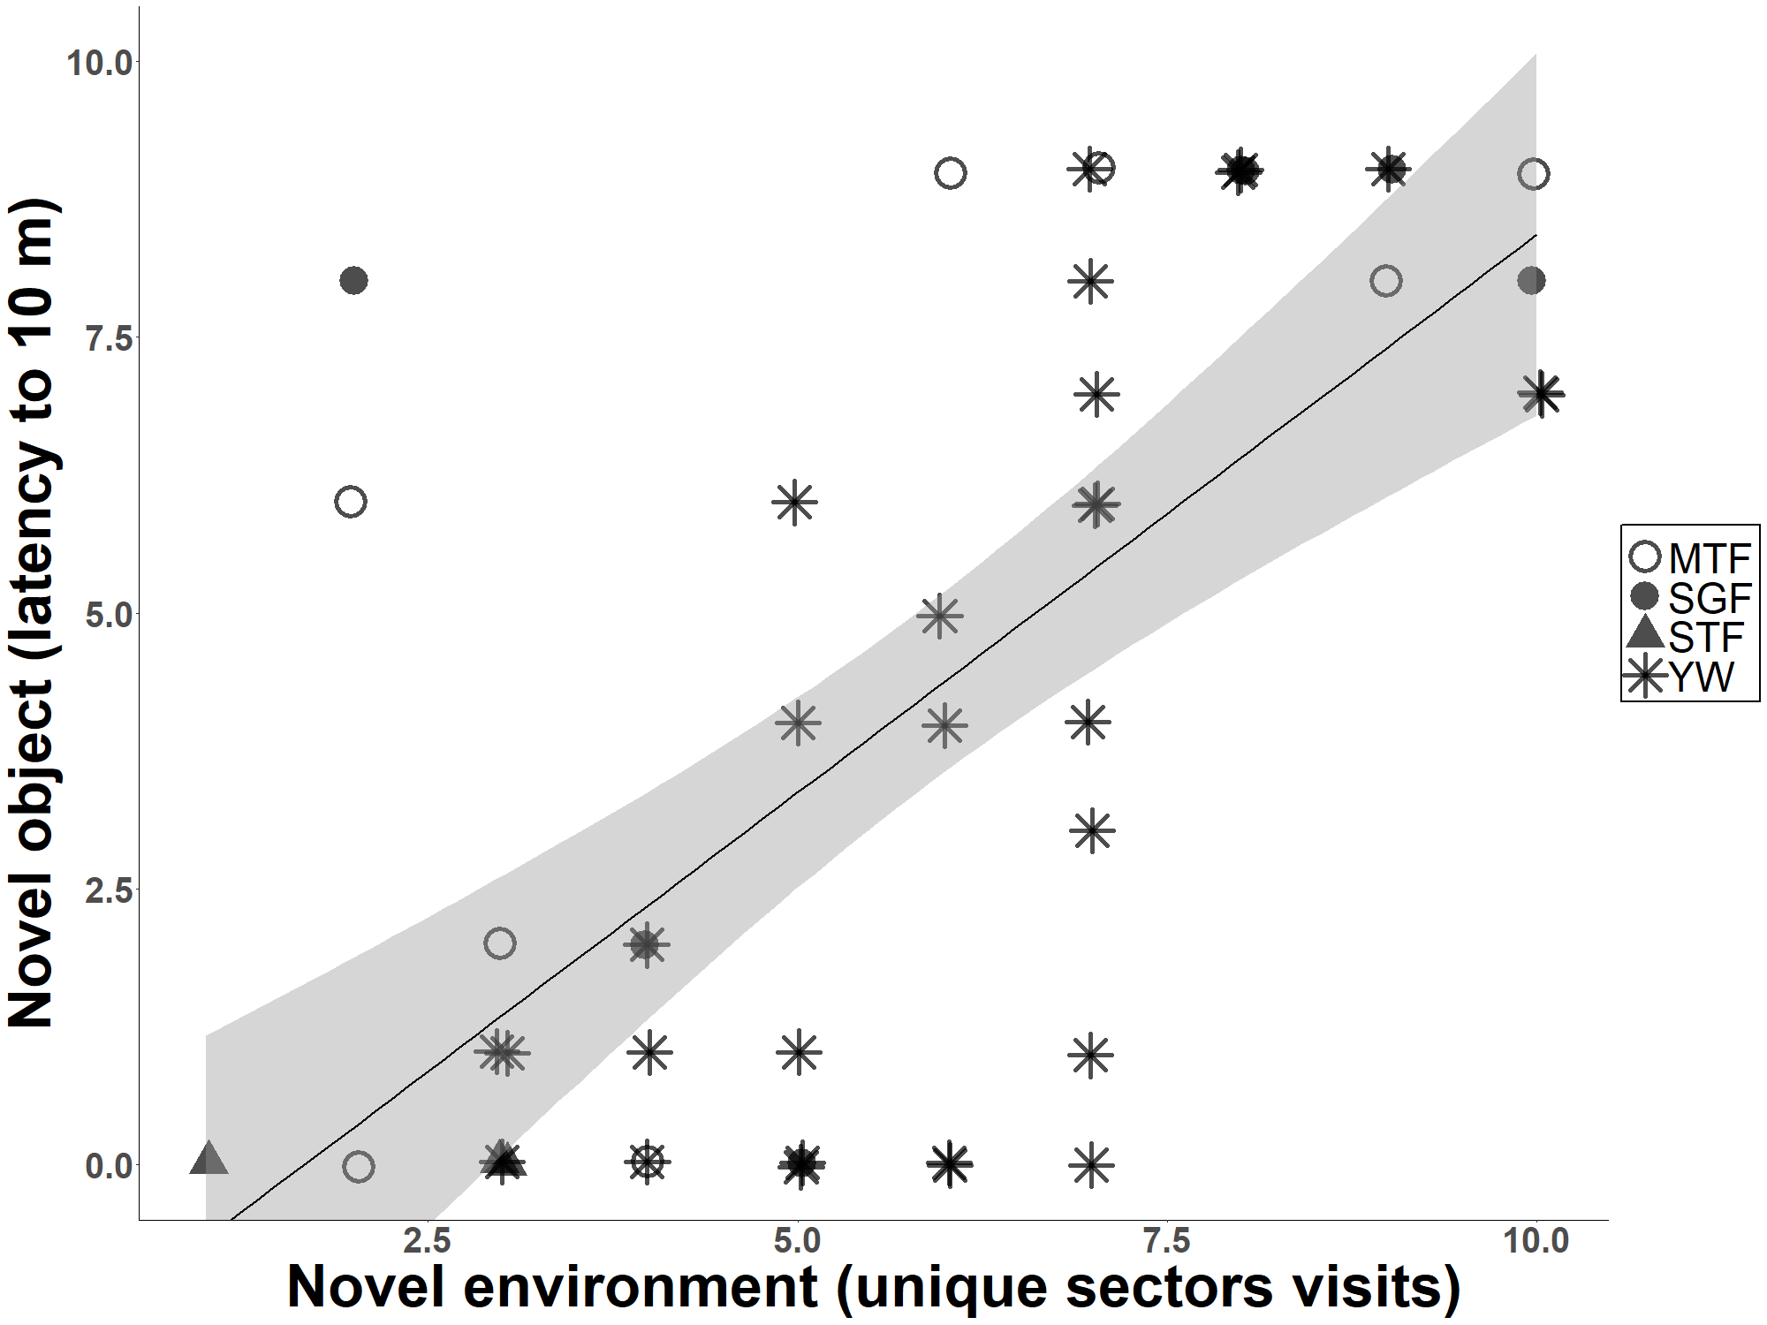

**Figure S4.** Percentage of birds per species per trial that approached within a 10-m radius during the novel object test (n = 262 individuals recorded across 53 trials). Species abbreviations: small ground finch (SGF), medium ground finch (MGF), small tree finch (STF), medium tree finch (MTF), Galápagos flycatcher (GFC), and yellow warbler (YW).

